18/09/2020

**Experiment No:4**

**POLYNOMIAL ADDITTION**

**AIM:**

Write a program to read two polynomials and store them in an array. Calculate the sum ofthe two polynomials and display the first polynomial, second polynomial and the resultant polynomial.

**DATA STRUCTURES USED:**

Arrays

**ALGORITHM:**

1. Initialise the exponent(row 0) and coefficient(row 1) and t1 (no of terms in a), t2 (no of terms in b)
2. Read the first polynomial and store it in the a coeff and exp arrays
3. Read the second polynomial to the p2 coeff and exp arrays
4. while i<=t1 || j<=t2

if i >= t1

c.exp[k] = b.exp[j]

c.coeff[k] = b.coeff[j]

j++, k++

else if j >= t2

c.exp[k] = a.exp[i]

c.coeff[k] = a.coeff[i]

i++, k++

else if a.exp[i] == b.exp[j]

c.coeff[k] = a.coeff[i] + b.coeff[j]

c.exp[k] = a.exp[i]

i++, j++, k++

else if a.exp[i] > b.exp[j]

c.exp[k] = a.exp[i]

c.coeff[k] =a.coeff[i]

i++, k++

else

c.exp[k] = b.exp[j]

c.coeff[k] = b.coeff[j]

j++, k++

1. print p3

**PROGRAM:**

#include<stdio.h>  
void main(){  
 int a[2][10],b[2][10],c[2][10],i,j,k,t1,t2;  
 printf("Enter the No. of Terms in Polynomial 1 : ");  
 scanf("%d",&t1);  
 for(i=0;i<t1;i++){  
 printf("Exponent : ");  
 scanf("%d",&a[0][i]);  
 printf("Coefficient for Exponent : ");  
 scanf("%d",&a[1][i]);  
 }  
 printf("\nEnter the No. of Terms in Polynomial 2 : ");  
 scanf("%d",&t2);  
 for(i=0;i<t2;i++){  
 printf("Exponent : ");  
 scanf("%d",&b[0][i]);  
 printf("Coefficient for Exponent : ");  
 scanf("%d",&b[1][i]);  
 }  
 i=0;j=0;k=0;  
 while(i<t1 || j<t2){  
 if (i>=t1){  
 c[0][k] = b[0][j];  
 c[1][k] = b[1][j];  
 j++, k++;  
 }  
 else if (j>=t2){  
 c[0][k] = a[0][j];  
 c[1][k] = a[1][j];  
 i++, k++;  
 }  
 else if (a[0][i]==b[0][j]){  
 c[0][k]=a[0][i];  
 c[1][k]=a[1][i]+b[1][j];  
 i++, j++, k++;  
 }  
 else if(a[0][i]>b[0][j]){  
 c[0][k]=a[0][i];  
 c[1][k]=a[1][i];  
 i++;  
 k++;  
 }  
 else{  
 c[0][k]=b[0][j];  
 c[1][k]=b[1][j];  
 k++;  
 j++;  
 }  
 }  
 printf("\nResultant Polynomial :\n\n");  
 for(i=0;i<k;i++){  
 printf("(%dx^%d)",c[1][i],c[0][i]);  
 if(i!=k-1)  
 printf("+");  
 }

}

**OUTPUT:**

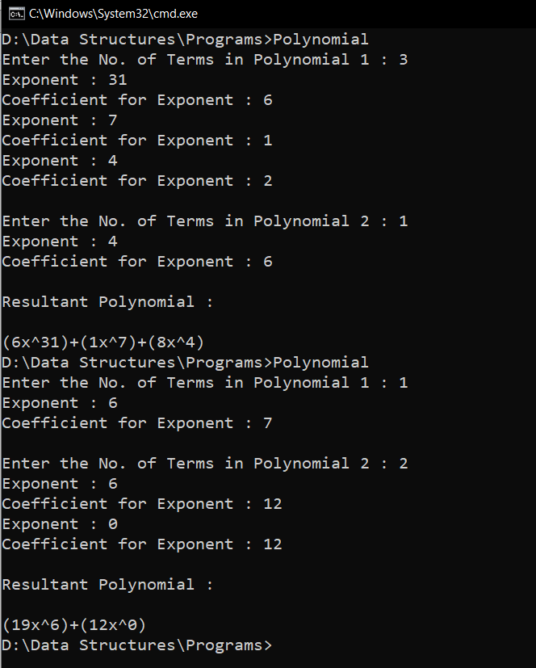

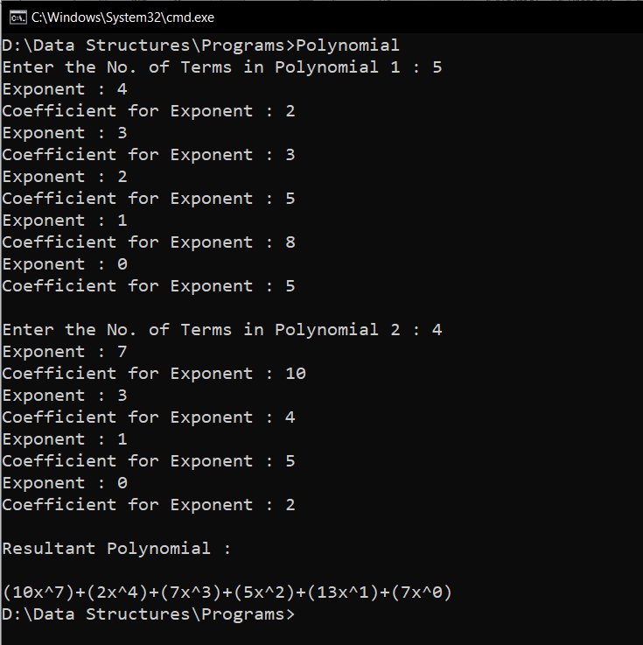

**RESULT:**

Two polynomials are stored in an array and are added to obtain a resultant polynomial.

All three polynomials are displayed.